REMEMBER TO CREDIT
ARTS MID-HUDSON!

Arts Mid-Hudson
Statewide Community Regrants Program

The following language MUST be used to recognize the grant:

This project is made possible with funds from the Statewide Community Regrants Program, a regrant program of the New York State Council on the Arts with the support of the Office of the Governor and the New York State Legislature and administered by Arts Mid-Hudson.

In addition, the use of the Arts Mid-Hudson logo (copied below) with the preceding written credit is required. Questions? Call 845-454-3222 or email grants@artsmidhudson.org
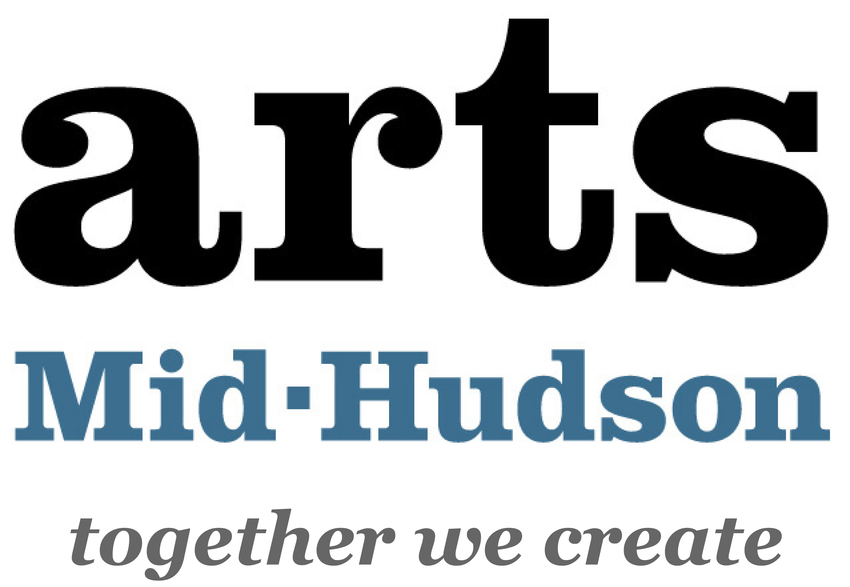

A digital version of the logo is available online at: www.artsmidhudson.org/grants-and-funding
under “Manage Your Grant or Award”
Posting photos on social media? Tag us/or use #ArtsMidHudson

IMPORTANT PLEASE READ: according to New York State Council on the Arts’ regulations, funded organizations may NOT directly credit the New York State Council on the Arts for supporting the project, verbally, in writing, or by including the New York State Council on the Art’s logo.

In Dutchess, Orange, and Ulster County, Arts Mid-Hudson MUST be directly credited for its support of the project following the above instructions.

