Please include Arts Mid-Hudson and Dutchess County’s seal as well as the funding language provided below on marketing and promotional materials.

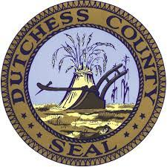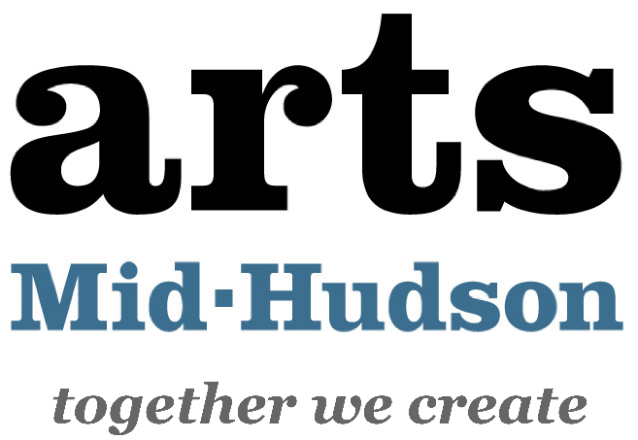

This project is made possible, in part,
through funding from
the Dutchess County Executive Office and administered by Arts Mid-Hudson.

